
Symbiosis Institute of Technology, Pune
CSE- Academic Year 2026-27
Java Programming – Lab Batch 2025-29
Lab Assignment No.: 9
Name of Student | Akshit Gawade
PRN No. | 25070122029
Batch | 2025-2029
Class | A1
Academic Year & Semester | Second Year  Semester III
Date of Submission | 11/7/2026
Title of Assignment: | Write a Java program to demonstrate the use of the final keyword with variables, methods, and classes.
Problem Statement  Learning Objectives | Write a Java program to demonstrate the use of the final keyword with variables, methods, and classes.  To implement the final keyword with variables, methods, and classes.
Theory | The final keyword restricts modification in Java programs. A final variable cannot be reassigned after initialization. A final method cannot be overridden and a final class cannot be inherited.
Program Code | Main:  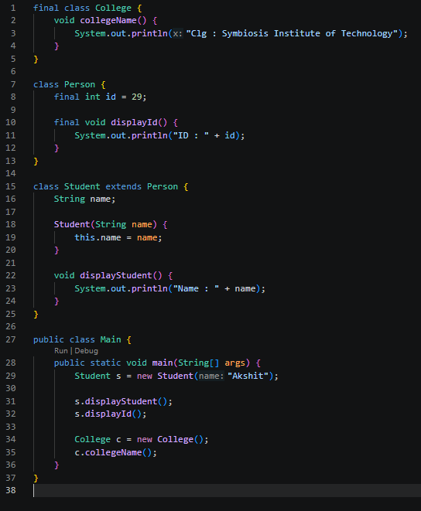
Output Screenshots | 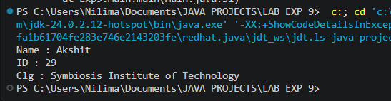
Exercise Qns  And  Program Code | Q1. Create a Bank Account program where account number is final and cannot be changed.  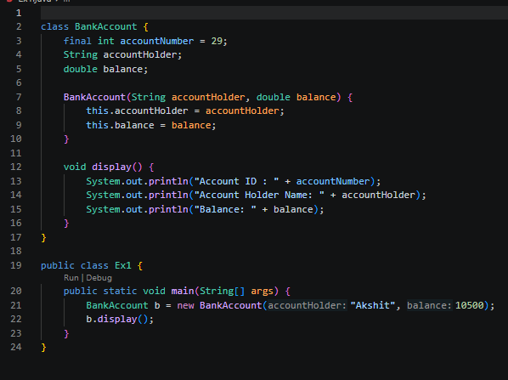  Q2. Create a Library Book Management program where the book ISBN is declared as final and cannot be changed once assigned. Display the book's ISBN, title, author, and price.  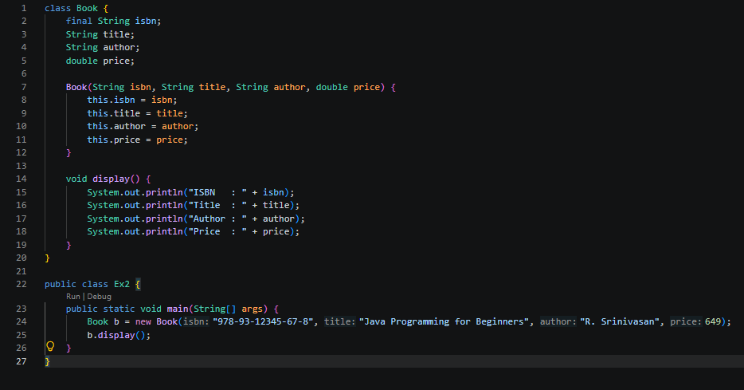
Output Screenshots | 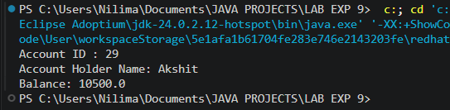  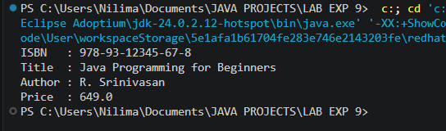
Conclusion | This assignment helped in understanding the concepts of inheritance and interfaces in Java through real-world examples. It demonstrated how inheritance enables code reusability by allowing child classes to inherit the properties and methods of a parent class, while interfaces provide abstraction by defining common behaviors that can be implemented by different classes. The implementation improved my understanding of object-oriented programming principles such as reusability, abstraction, and polymorphism. These concepts are widely used in developing desktop applications, web applications, Android applications, enterprise software, e-commerce systems, banking systems, and other real-world Java applications that require modular, flexible, and maintainable code.

